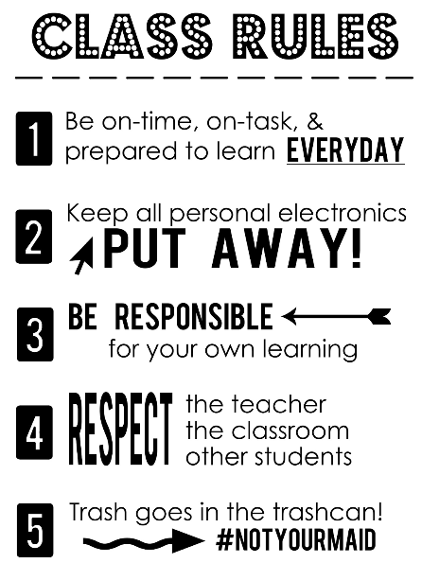

Tutoring with Mrs. Kerchner

Begins during 1st session of After School Academy

3:00-4:30

Daily Supply List:

* School Issued Laptop
* Pencils
* 1½ ” binder or larger

Cell Phone Policy

Phones will be collected daily at the beginning of class daily.



Mrs. Kerchner & Ms. Wofford

Intensified Algebra

[CBKerchner@worcesterk12.org](mailto:ckerchne@wcboe.org)

SMWofford@worcesterk12.org

STEPHEN DECATUR HIGH SCHOOL

410-677-5146

stephen-decaturhs.weebly.com

GRADING POLICY:

HOMEWORK 20%

CLASSWORK 30%

TEST/QUIZZES/PROJECTS 50%

Class Website:

[www.kerchmath.weebly.com](http://www.kerchmath.weebly.com)

Curriculum:

Students enrolled in Algebra 1 will acquire conceptual understanding and skill proficiencies in algebraic content consistent with the Maryland College and Career Ready Standards. Students will apply rigorous algebraic knowledge and skills to numerous real world applications through a variety of performance tasks and through the use of technology. Students will continue their study of algebraic relationships involving numbers, variables, exponents and operations including expressions, equations and inequalities, linear quadratic, and other non-linear functions, and descriptive statistics. Students enrolled in Algebra 1 will take the MCAP assessments upon completion of Algebra 1 Part 2.

HOMEWORK POLICY

* Homework will be posted in class daily, and on the homework calendar on my website.
* Homework will be assigned every night except weekends and test days.
* Homework is graded on accuracy!
* Homework corrections are due by the end of the topic.
* Late homework will be accepted for half credit.

MAKE-UP WORK

Make-up work will be accepted in accordance with the county policy.

PARENTS

Dear Parents and Guardians,

As the new year begins, we would like to introduce ourselves. We are Carrie Kerchner and Sarah Wofford, and we are your child’s Math teachers this year.

We want this semester to be a successful one for both you and your child, and We believe that parent-student-teacher communication is vital in order to have a successful school year. Working together as a unit, we will be able to support and provide for all the needs of your child.

Instead of asking you to sign the class syllabus and return it to school, we are asking that you email us instead. This will allow us to save your email address to our class list for future communication.

After you review our class syllabus, please email us with the following information:

* Your name
* Your child’s name
* Your preferred method of contact: email, phone call, etc.

We are looking forward to an exciting and successful year with your child!

Sincerely,

Mrs. Carrie Kerchner & Ms. Sarah Wofford

[CBKerchner@worcesterk12.org](mailto:CBKerchner@worcesterk12.org) [SMWofford@worcesterk12.org](mailto:SMWofford@worcesterk12.org)

